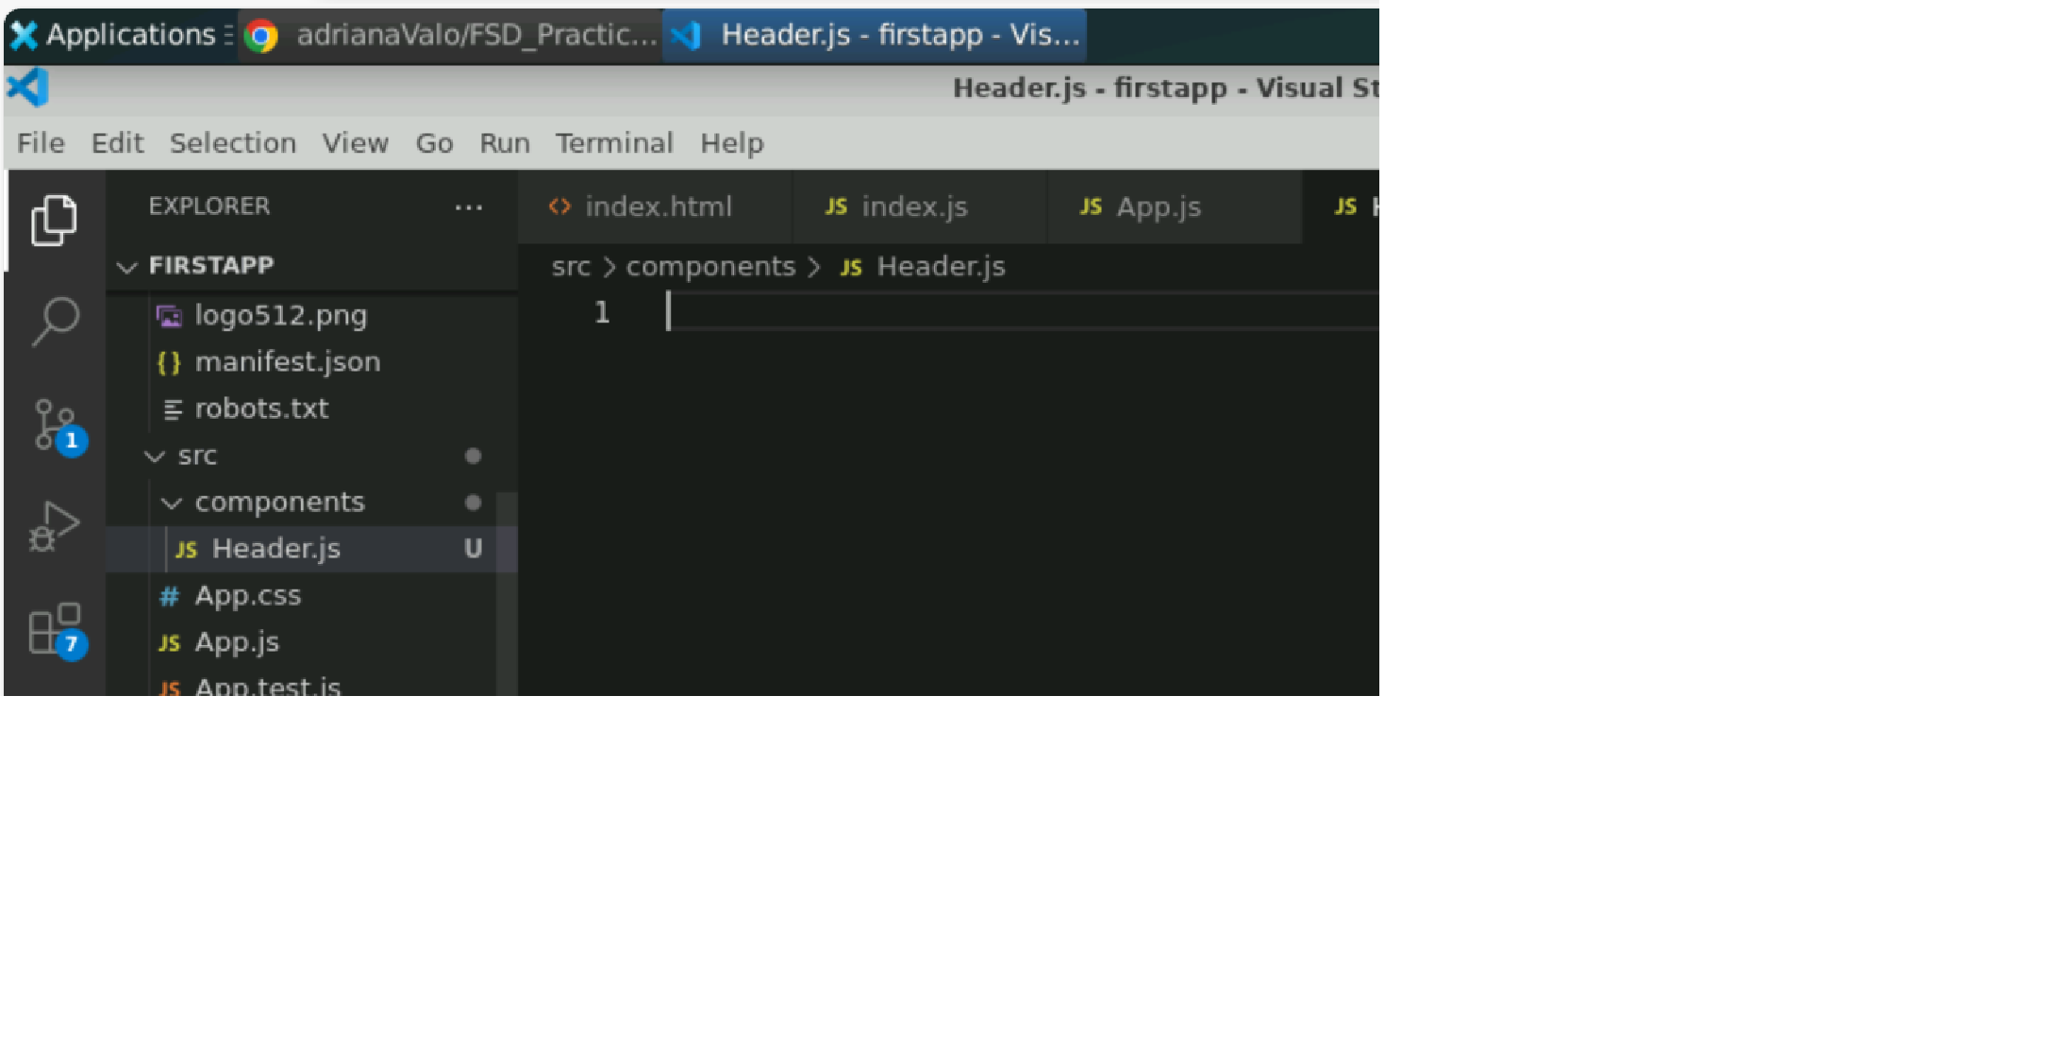

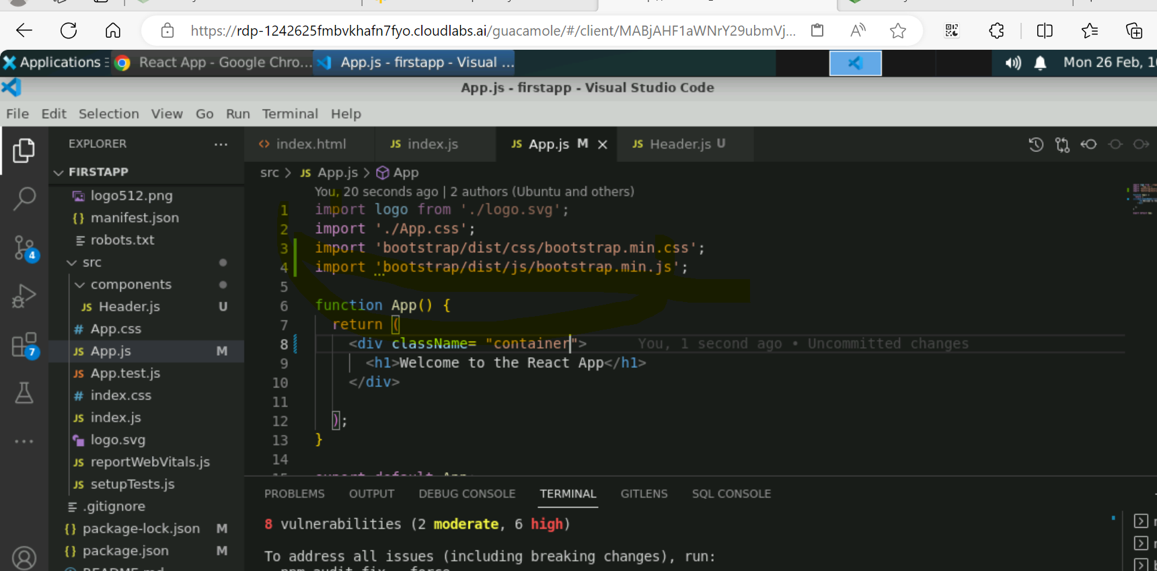

Steps:

1. Npx create-react-app secondapp
2. Cd secondapp
3. Npm start
4. App.js-> remove the structure
5. Bootstrap- > get started
6. Npm install react-bootstrap bootstrap
7. Import css from the webpage into the App.js
8. Import the js link also
9. Create a div into App.js
10. Add bootstrap class to the header “container”

App.js

import logo from './logo.svg';

import './App.css';

import 'bootstrap/dist/css/bootstrap.min.css';

import 'bootstrap/dist/js/bootstrap.bundle.js';

function App() {

return (

<div className="container">

</div>

);

}

export default App;

Index.js

import React from 'react';

import ReactDOM from 'react-dom/client';

import './index.css';

import App from './App';

import reportWebVitals from './reportWebVitals';

import Header from './components/Header';

import Slider from './components/Slider';

import Featured from './components/Featured';

import Footer from './components/Footer';

import UseCase1 from './components/JSXLearning/UseCase1';

import UseCase2 from './components/JSXLearning/UseCase2';

import UseCase3 from './components/JSXLearning/UseCase3';

import UseCase4 from './components/JSXLearning/UseCase4';

const root = ReactDOM.createRoot(document.getElementById('root'));

root.render(

<div>

<App />

<Header/>

<Slider/>

<Featured/>

<UseCase1/>

<UseCase2/>

<UseCase3/>

<UseCase4/>

<Footer/>

</div>

);

// If you want to start measuring performance in your app, pass a function

// to log results (for example: reportWebVitals(console.log))

// or send to an analytics endpoint. Learn more: https://bit.ly/CRA-vitals

reportWebVitals();

==========================================================================